Catholic Sensibility
30 June 2012

Two Weeks of Worthy Women: Thea Bowman

Posted by catholicsensibility under Fran Rossi Szpylczyn

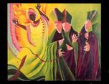

As the USCCB’s Fortnight for Freedom continues, we take an alternative track here. I’ve been promising more voices, and today, guest blogger Fran Rossi Szpylczyn contributes a stirring testimony for a stirring woman of our times.
No review of worthy women of our Church can exclude the woman who would not be excluded at any cost – Sister Thea Bowman, FSPA. As a woman religious who stated that she wanted to “go home like a shooting star,” she also lived that way; her life was like a blazing tale of God’s glory, against the sky of her life.
--Todd Flowerday

Born to a teacher and a doctor in Yazoo City, Mississippi on December 29, 1937 and named Bertha Bowman, she was reared as a Methodist in Canton, Mississippi. Her beginnings were humble but noble, given that her grandparents were slaves. An only child who was extremely bright. At the age of 9 asked about becoming Catholic, which her parents agreed to. Bertha’s, (soon to be Thea’s) vocation began like the birth of a star, with various elements coming together to create a unique light.
At the age of 15, she moved to La Crosse, Wisconsin, home of the Franciscan Sisters of Perpetual Adoration, to begin her novitiate. These sisters were her teachers in Mississippi, and she was profoundly influenced by them. As the only African-American in the FSPA community, Thea encountered challenges in retaining her own cultural identity, which for her, was at the heart of who she was as a child of God.
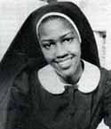
Gifted in many ways, Thea excelled in her studies and earned a PhD in Linguistics and English Literature from the Catholic University of America. In 1989, she also received an honorary Doctor of Religion from Boston College. Her work as a woman religious found her in the classroom where she generously shared her knowledge, along with God’s love, with great joy. Having taught elementary, secondary and ultimately university level students, Sister Thea illumined many minds through her work as a teacher and professor.
At the core of her vocation was a fiery passion for unity and justice. Breaking down barriers and inviting all to live as one in Christ was her focus, above all else. Sister Thea had an enormous drive to communicate Christ across barriers, no matter what the cost. If she could facilitate bringing people together through and in God, that is what she would do.
Eventually Sister Thea was asked to become the consultant for Intercultural Awareness in the Diocese of Jackson, Mississippi. This was a role in which she flourished by breaking down barriers at home and afar, by bringing people together. Sister Thea often made over 100 speaking appearances a year. Her gift to shine light in dark places, and to reveal Christ as unifier and redeemer was realized in many ways. She was undaunted by challenge, and always pushed forth with her beloved Jesus.
Thea was also passionate about the revelation of African roots and the impact of those roots in the Church. For Thea, inclusion was not negotiable and recognition of how we are all created in God’s image was essential.
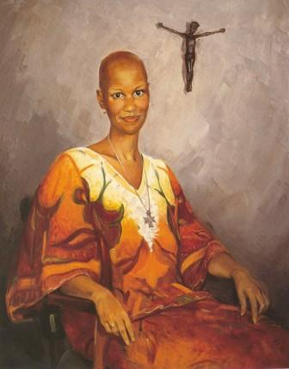
In 1984 Thea’s parents died and then she was diagnosed with cancer. When confronted with this disease her response was typical of her resolve, as she said she would “live until I die.” And live she did, for several more years. Thea kept going, making her final years, burn with the brightest fire.
In 1987, Mike Wallace interviewed her for 60 Minutes. Reminding us that we all have something to give, she told Wallace, “I think the difference between me and some other people is that I am content to do my little bit. Sometimes people think they have to do big things in order to make change. If each one of us would light the candle, we’ve got a tremendous light.”
In June of 1989, the US Bishops were meeting and they asked Sister Thea to address them on the meaning of being black and Catholic. It was here that she began an address by asking what it meant to be black and Catholic out loud and replying to herself, and the bishops, by singing, “Sometimes I Feel Like A Motherless Child.” It is worth noting that as she was introduced, the bishop introducing her joked that she was on 60 Minutes and not because she was the subject of a “criminal investigation.” (Hearing those words from a bishop, at this time, made me wince with discomfort!)
Sister Thea then launched into a wide ranging talk, filled with her signature passion, and all delivered from her position in a wheelchair. If you watch the video of the talk, well worth your 32 minutes, you will see a wide range of reactions and emotions on the bishops’ faces, including eyes that are welled-up with tears. At the end of the talk Sister Thea asked the bishops to cross arms and clasp hands and to join her in singing, “We Shall Overcome.”
Most of the bishops appeared to follow her instructions, but some did not. Some of the bishops appeared, to my eye anyway, visibly uncomfortable, others appeared moved. The video of her talk to them is a testament to a worthy woman living a remarkable moment.
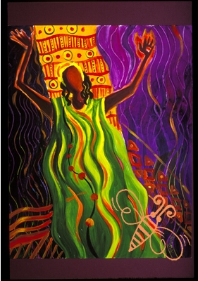
Brother Mickey O’Neill McGrath wrote about Sister Thea in “This Little Light of Mine.” (The image at the top left of this post, as well as the one to the right, are from his website and are gratefully used with his permission.)
Brother Mickey often shares an anecdote about Sister Thea’s meeting with the bishops. In what sounds like an astounding moment, according to what he heard from someone who was present at the meeting. Apparently as her wheelchair was being wheeled out of the hall, the bishops formed an honor guard and knelt before her as the chair passed by.
Sister Thea remained focused on a vision of strength in unity throughout her life. She would often say, “You walk together and you won’t get weary. You might get tired, but you won’t get weary.” May her legacy be to keep us together, tired perhaps, as we continue to encounter injustice, but to never grow weary, as we walk together in Jesus’ name.
She died March 30, 1990 in Canton, Mississippi.

Watch: Sister Thea Bowman to the US Bishops from Rocco Palmo on Vimeo.

Catholic Sensibility writers
- about Todd Flowerday
A Roman Catholic lay person, married (since 1996), with one adopted child (since 2001). I serve in worship and spiritual growth in a midwestern university parish.

about Neil
Neil has been a blogging collaborator for the past several years on Catholic Sensibility. He brings his unique experiences from theology, spirituality, and the ecumenical sphere. Pay special attention to each one of his posts.

You can find more of Fran’s work at her personal blog, There Will Be Bread and also at The Parish Blog of St. Edward the Confessor.

From Google: Catholic Sensibility
Corrections by CMS 7.31.2012

