**Job Description**

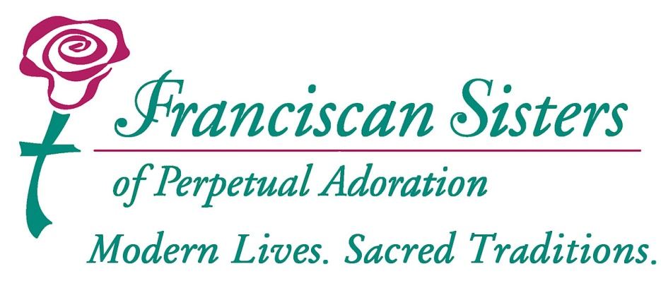

**Job Title:**

Liturgy Administrative Assistant

**Reports To:**

Liturgist

**FLSA Classification:**

Non-Exempt.

**Creation/Last Revised:**

1/2023

**____________________________________________________________**

**Job Summary:**

The person in this position provides administrative support for the Liturgist at St. Rose Convent.

**Job Type:** Part-Time; Works 20 hours per week.

**Education & Experience:**

* Two or more years of administrative support experience preferred.
* Previous customer service experience required.
* Ability to process routine correspondence, memos and reports normally acquired through completion of course work or experience.
* Working knowledge of Roman Catholic liturgy and music ministry preferred.
* Proficient in the use of some or all of the following software to include Windows, Ministry Scheduler Pro, OneLicense, Microsoft Office including Word, Excel and Publisher; Google Suite including Gmail, Calendar, Contacts, and willingness to learn other computer software.
* Knowledge of grammar, punctuation and rules used in proofreading and the ability to apply them.

**License requirements:**

**Essential Duties:**

* Identifies with, shares in, and displays a commitment to the mission, philosophy and overall strategies of the Franciscan Sisters of Perpetual Adoration.

**Weekly**

* In the absence of the Liturgist, answer phone and transfer calls or take messages.
* Provide administrative services as requested.
* Carry out routine tasks necessary for liturgical services at St. Rose, including preparation and distribution of all department communications through email, posters and mail distribution.
* Prepare the petitions for general intercession for daily Mass.
* Receive, schedule and record Mass intention stipends.
* Maintain inventories of liturgy office materials, including toner and copy paper.
* Run errands as needed.
* Prepare weekday and Sunday song schedules.
* File music and worship aids as needed.
* Perform preventive piano care.
* Collect mail and distribute as needed.

**Monthly**

* Maintain “Book of Life”.
* Prepare and distribute ministries schedules using Ministry Scheduler Pro.
* Assist to create, modify and print worship aids for Liturgies.
* Record and distribute Liturgy Committee meeting notes.
* Create, maintain and distribute monthly events calendar.
* Post monthly reporting to OneLicense website.

**When Needed**

* Maintain birthday listings and days of passing for sisters, affiliates and employees.
* Design and decorate altar and vestibule displays for significant liturgical seasons and holy days.
* Assist with funeral liturgies as needed.
* Assist with special projects and tasks as assigned.

**\*\*Other Duties as Assigned\*\***

**Knowledge, Skills, and Abilities:**

To perform this job successfully, an individual must be able to perform each essential duty satisfactorily. The requirements listed below are representative of the knowledge, skill, and/or ability required.

* Strong attention to detail. Emphasis on accuracy, neatness and meticulous proofreading.
* Exceptional communication skills, with a focus on rapport-building and listening.
* Must be able to adapt to changing work priorities; communicate with diverse groups; meet deadlines and schedules; work as part of a team, and work with frequent interruptions.
* Ability to occasionally work after hours or weekends.
* Handle sensitive and confidential materials in a discreet, professional manner.
* Must be able to handle multiple tasks simultaneously and accurately while providing excellent customer service.

**Physical Requirements:**

The physical demands described here are representative of those that must be met by an employee to perform the essential functions of this job successfully.  Reasonable accommodations may be made to enable individuals with disabilities to perform the essential functions.

While performing the duties of this job, the employee is regularly required to sit, use hands to finger, handle or feel; talk and hear. The employee is occasionally required to stand, walk, and reach with hands and arms. The employee must regularly lift and/or move up to 10 pounds, frequently lift and/or move up to 25 pounds and occasionally lift and/or move up to 50 pounds. Specific correctable vision abilities required include close vision, distance vision, color vision, peripheral vision, depth perception and ability to adjust focus.

**Work Environment:**

The work environment characteristics described here are representative of those an employee encounters while performing the essential functions of this job.

The noise level is usually moderate.

**Prerequisite**: Physical exam, Tuberculosis screening test, drug screen, criminal background check

**Disclaimer clause**

The above statements are intended to describe the general nature and level of work required of the job. They are not meant to be an exhaustive list of all responsibilities, duties and skills required. FSPA reserves the right to change job responsibilities, duties and hours as needed.

I have read and understand the job description. I agree to accept the responsibilities and duties as outlined.

______________________________________                    _____________________

Signature                                                                                 Date